1.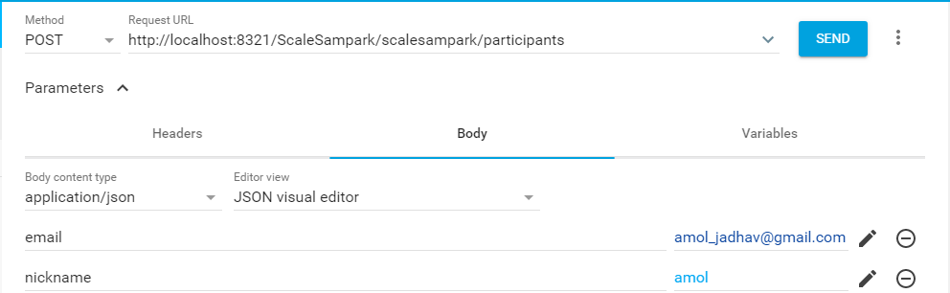
URL : http://localhost:8321/ScaleSampark/scalesampark/participants
Method : POST
Above request is to add new participant
2. 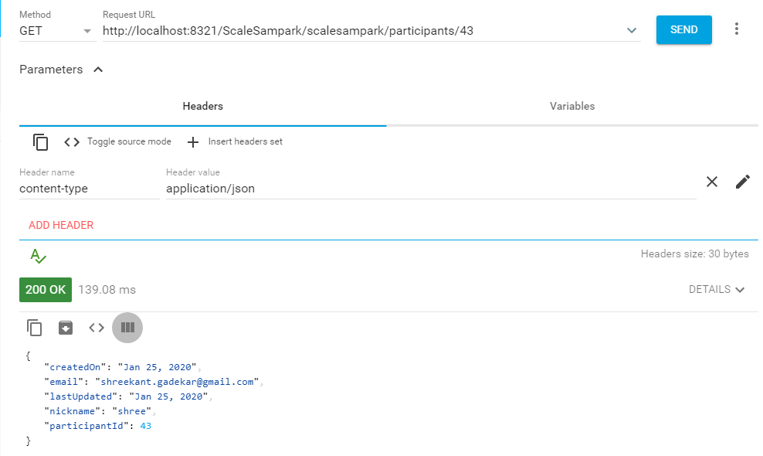
URL : http://localhost:8321/ScaleSampark/scalesampark/participants/43
Method : GET
Above givent request is to get the details of given participant id.

3. 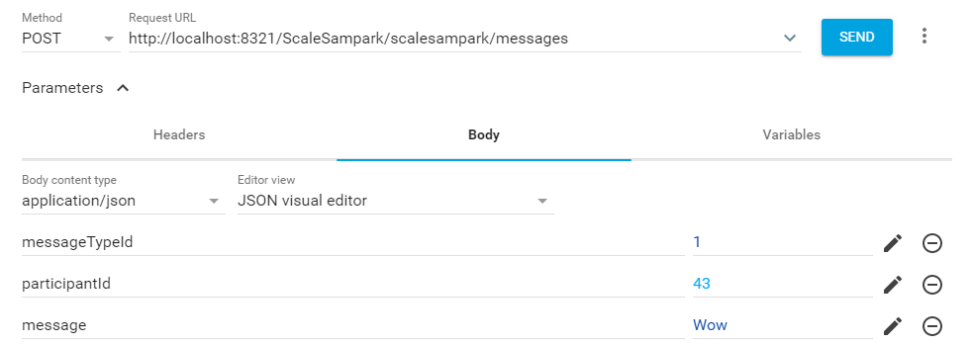
URL: http://localhost:8321/ScaleSampark/scalesampark/messages
Method: POST
Above given request is to add/send message to conversation.
4. 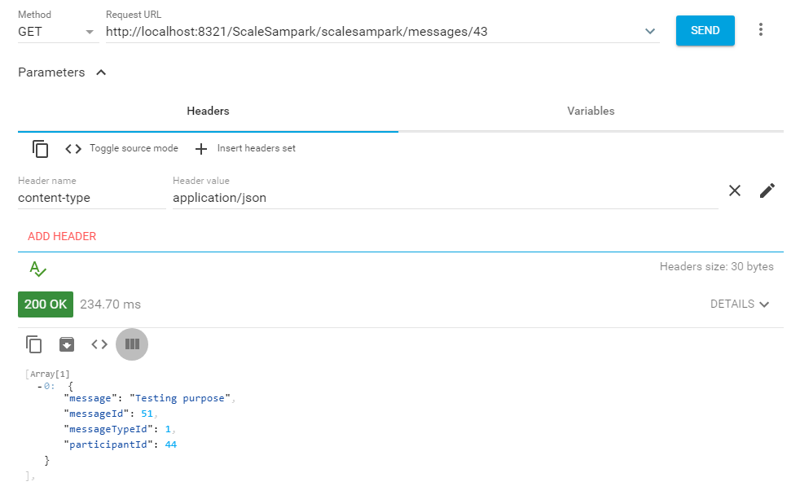
URL: http://localhost:8321/ScaleSampark/scalesampark/messages/43
Method: GET
Above given method is to get unseen messages by participant id 43 which also updates his last seen
5. 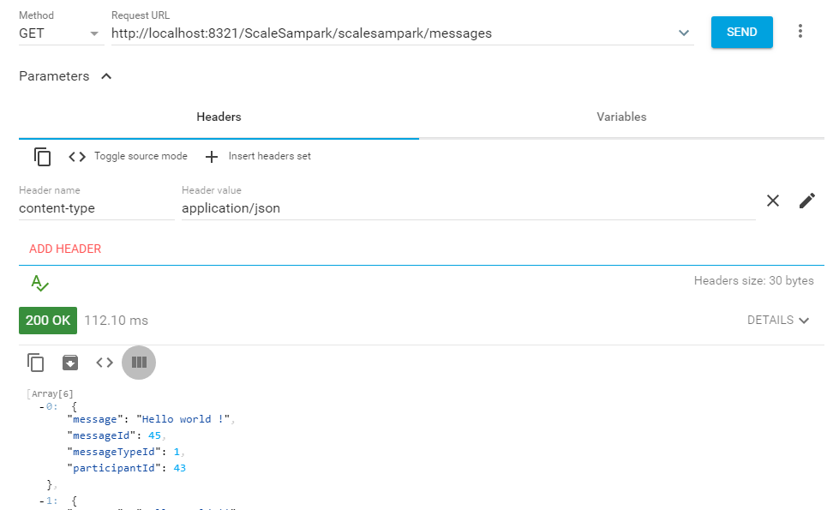
URL: http://localhost:8321/ScaleSampark/scalesampark/messages
Method: GET
This request is to get all the messages of the conversation.
6. 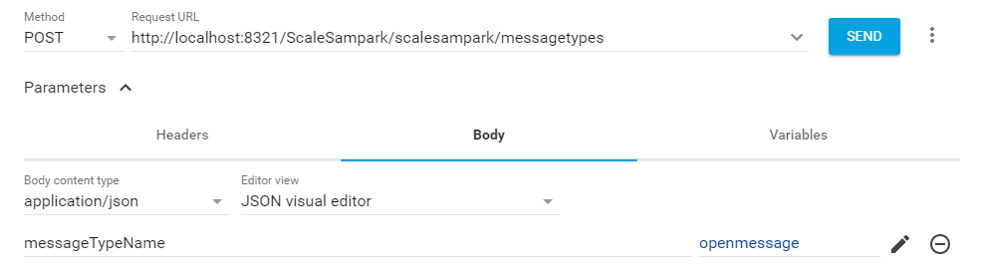
URL: http://localhost:8321/ScaleSampark/scalesampark/messagetypes
Method: POST
This request is to add the new message type

7. 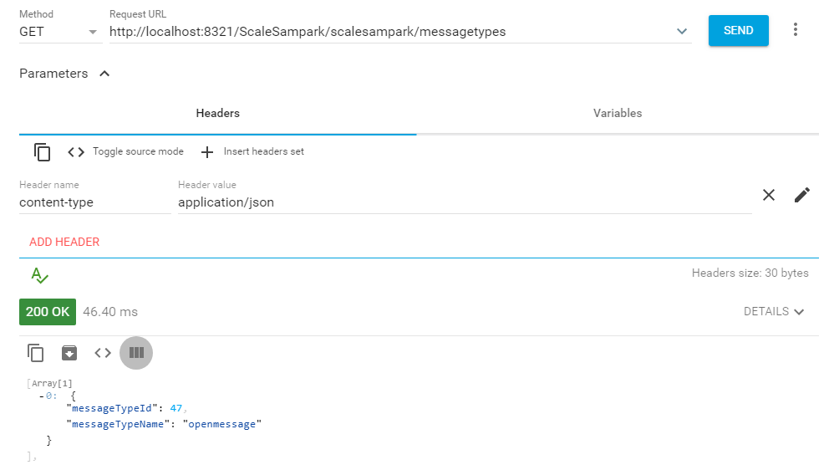
URL: http://localhost:8321/ScaleSampark/scalesampark/messagetypes
Method: GET
This request get all the message types.

8. 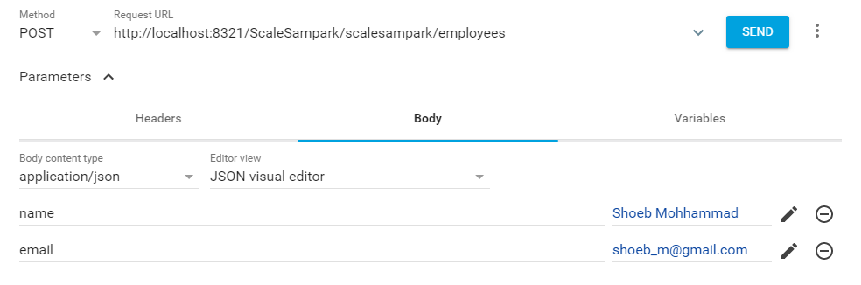
URL: http://localhost:8321/ScaleSampark/scalesampark/employees
Method: POST
This request is to add the employee. (additional API)
9. 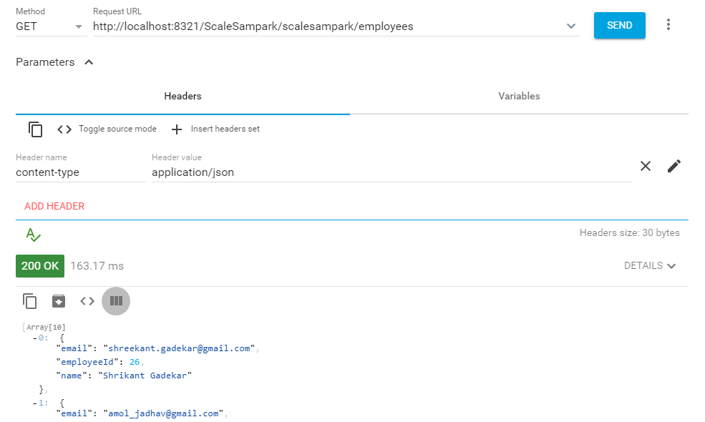
URL: http://localhost:8321/ScaleSampark/scalesampark/employees
Method: GET
This request is to get the list of all employees.

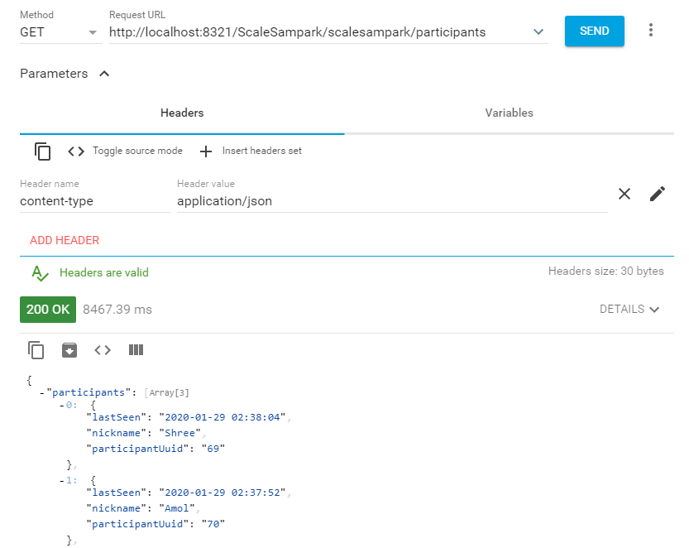

Some changes in response in request.

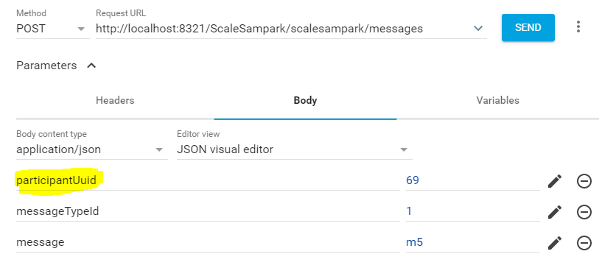
For this api parameter name has been changed from participantId to participantUuid.

